**CAPACITORS**

**What is Capacitor?**

A Capacitor is an electronic device capable of temporarily storing electrical energy. It would be quite possible to confuse this definition with the one for a battery. There is, however, an essential difference between the two. A battery stores electrical energy, releasing it by chemical action, whereas a capacitor stores the actual electrons themselves. In other words, a battery is essentially a chemical device, and a capacitor is an electronic device. Although a capacitor is not a battery, it can exhibit some of the characteristics of a battery. In addition, capacitors are capable of acting like resistors, rectifiers, or inductors. To add to the confusion, they can exhibit these characteristics all at the same time and still perform the functions of a capacitor.

**Units and Symbols of Capacitors:**

**Symbols:**

Two common capacitor symbols are widely used in electronics. One symbol represents polarized capacitors, while the other represents non-polarized capacitors.

In the diagram below, the symbol featuring a curved plate indicates a Polarized Capacitor. The cathode (−ve) of the capacitor is denoted by the curved plate, whereas the anode (+ve) is represented by the straight plate. At times, a plus sign is also included to indicate the +ve side.

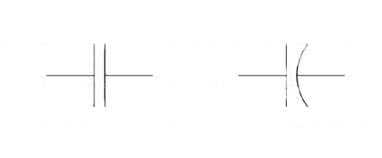

**Polarized**

**Non-polarized**

**Units:**

The SI unit of capacitance is farad (*Symbol*: F). The unit is named after the Great English Physicist, [Michael Faraday](https://www.bbc.co.uk/history/historic_figures/faraday_michael.shtml).

 One faraday is the unit of electrical capacitance, the ability of a body to store an electrical charge, in the SI units equivalent to 1 coulomb per volt.

**1 F =**

**History of Capacitors:**

1. **At Beginnings (1745-1746):** The evaluation of Capacitors was started by two Pioneering scientists, Ewald Georg von Kleist and Pieter van Musschenbroek, in the mid-18th century discovered the fundamental principles of the capacitor, independently. A German clergyman, Kleist and a Dutch physicist, Musschenbroek both illustrated their experiments which involves the storing of electric charge which is known as the Leyden jar. The device is made-up of glass jar which is coated inside and out with metal foil, with a metal rod immersed through a cork stopper. It could store electrical energy for later discharge when the metal rod was charged and touched.
2. **At 1750 by Benjamin Franklin:** The American polymath Benjamin Franklin, known for his experiments with electricity, was got interested by the Leyden jar. Franklin came up with “Battery” to define a connection in series with Leyden jars, and he conducted revolutionary research on capacitance, which includes the famous kite experiment that demonstrate the connection between lightning and electricity.
3. **19th Century:** The development of Practical Capacitors. Throughout the 19th century, inventors and scientists improved the design and expanded the uses of capacitors. One major improvement was introduction of dielectric materials like glass, wax and paper which enhanced the efficiency of capacitors by isolating the charged plates. By innovation brought about to the creation of capacitors with the great energy storage capacity.
4. **20th Century:** In 20th century Electrolytic Capacitors was developed by Warren de la Rue in 1866. Electrolytic Capacitors utilizes an electrolyte-soaked paper as the dielectric, enabling smaller designs and increases capacitance value. These capacitors became a crucial in early radio technology and in wide range of electronic devices.

**Miniaturization and Morden Applications:** In the mid-20th century a electronics industry distinguished the miniaturization of capacitors, with surface-mount technology (SMT). This allows the development of smaller and more advanced electronic devices, expending from transistor radios to microprocessors. Capacitors was utilized in power supplies, signal filtering, timing circuits and energy storage.

1. **21st Century:** In modern times, capacitor technology has kept advancing, through the creation of sophisticated types like supercapacitors and tantalum capacitors. Supercapacitors provides high energy density and fast charge/ discharge cycles, making them well-suited for applications such as hybrid vehicles and sustainable power systems. Tantalum capacitors deliver reliable performance under harsh conditions, making them suitable for aerospace and medical devices.

The history of capacitors is a reflection of human brilliance and the constant drive for innovation in electrical engineering. Emerging from simple beginnings with Leyden jars to the sophisticated capacitors driving today’s electronic advancements, these innovations have made remarkable strides in supporting technological growth. As we step into a new era of increasing electric mobility and renewable energy innovations, capacitors will certainly continue to play a crucial role in shaping our electrified world.

**Functions of Capacitors:**

* **Stores Energy:** Capacitors are best for storing electrical energy. They can store a smaller amount and can store a large amount, depending on what you want to achieve with them.
* **Voltage Source:** The charges create a potential difference across the plate of a capacitor. Due to the potential difference, the capacitor acts as a voltage source in the circuit.
* **Instantaneous current provider:** Sometimes we need a source that can give us high current in a very short time like instantaneous.
* **Noise Filter:** The voltages and currents, they contain impurity in the form of noise. Noises are the unwanted signals suppressed upon the want or desired signal in a circuit.
* **Frequency harmonics blocker or eliminator:** Every signal is a combination of [frequency](https://en.wikipedia.org/wiki/Frequency) harmonics. In simple words, every signal is created from the combination of small signals with different frequencies.
* **DC blocker:** If the input signal contains DC voltage. This DC voltage may disturb the biasing of our amplifier circuit. To avoid such a situation, we put a capacitor to block that DC.
* **Tuning:** Tuning is the term used in communication. The back-end electronics circuit is responsible for this tuning operation. And capacitors are key components of these circuits.
* **Sensors:** The capacitance value of a capacitor depends on the area and distance between the plates as well as on the dielectric constant. Area and length are hard to change in practice. But the dielectric constant is something we can use to carry the capacitance. Area and length are hard to change in capacitance helps us to use a capacitor as a capacitance sensor in various applications.
* **Impedance matching:** Matching is very critical in circuits for the maximum power flow. If there is a mismatch, a portion of power will be reflected, which is not desirable.



**Construction of a capacitor:**

The basic construction of all capacitors is similar. The construction of capacitor is very simple. A capacitor is made of two electrically conductive plates placed close to each other, but they do not touch each other. These conductive plates are normally made of materials such as an aluminium, brass, or copper.

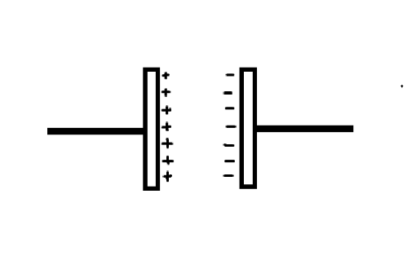

**+ Holes**

**- Electrons**

**Negatively charged**

**Positively charged**

**Charge conductive plates**

**Connecting wires**

**Electrical field**



The conductive plates of a capacitor is separated by a small distance. The empty space between these plates is filled with a non-conductive material or electric insulator or dielectric region. The non-conductive material or region between the two plates may be an air, vacuum, glass, liquid, or solid. This non-conductive material is called dielectric.

The two conductive plates of the capacitor are good conductors of electricity. Therefore, they can easily pass the electric current through them. The conductive plates of the capacitor also hold the electric charge. In capacitors, these plates are mainly used to hold or store the electric charge.

A dielectric material or medium is the poor conductor of electricity. They cannot pass electric current through them. In capacitors, the dielectric medium or material block the flow of charge carriers (especially electrons) between the conductive plates. As a result, the electric charges that try to move from one plate to another plate will be trapped within the plate because of the strong resistance from the dielectric.

If we place the conductive medium between these plates, the electric charges flow easily from one plate to another plate. However, electric current flow between the plates is not desirable. It indicates the failure of capacitor.

We know that electric current is the flow of charge carriers whereas electric force or electric field is the property of electric charges. Dielectric material does not allow the flow of charge carriers, but they allow the electric force, electric charge, or electric field produced by the charged particles (electrons). As a result, when charge is build up on the two plates, a strong electric field is generated between the two plates.

**Working Principle of a Capacitor:**

As we know that when a voltage source is connected to conductor it gets charged say by a value Q. And since the charge is proportional to the voltage applied, we can say that:

**Q∝V**

In order to equate the charge Q and voltage V.

Q=CV, where C is the capacitance of the conductor.

C=Q/V, the value of C is dependent on various factors as given hereunder.

* The plate/conductor area. Larger the plate area greater is the charge accumulation on it.
* The gap between the plates. With a large gap between the plates, the capacitance gets reduced due to a reduction in charge binding/field force or reduction in permittivity.
* The dielectric medium. The value of capacitance can increase if we use a material with high permittivity. As an example, the relative permittivity of air is approximately= 1, while that of glass/ceramic is approximately more than 7.
* All these factors are of utmost importance while designing a capacitor. The mathematical expression for the same is:

Where,

C = Capacitance in Farads.

ε = Permittivity of dielectric (absolute, not relative).

A = Area of plate overlap in square meters.

d = Distance between plates in meters.

The[energy](https://www.watelectrical.com/introduction-on-energy-meter-different-types-of-energy-meters/) stored in a capacitor is given by the formula:

and

This is also known as Capacitor Formula.

It may be added here that in order to achieve desired capacitance a series and parallel combination can be used as shown in the image below where Cp is the resultant capacitance in parallel and Cs is the resultant capacitance in series.

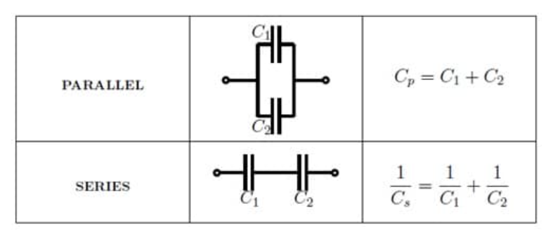

**The Capacitor in Series and Parallel**

**Capacitor Theory:**

* **Energy Absorption:**

When a capacitor charges or discharges, energy is used. Most of it is stored, but some is lost as heat due to the resistance (R₂) of the leads and plates. This power loss (PR loss) occurs in both charging and discharging cycles. Faster cycles increase heat buildup, which can damage the capacitor. To reduce this, capacitors are often made larger than their basic electrical requirements.

* **Power Factor:**

Power factor is the ratio of power lost to total power used in charging a capacitor

and is affected by frequency, temperature, dielectric material, voltage stress, and resistance, while resonance effects, incorrect replacements, and improper lead lengths can cause overheating and failure, making it essential to use the exact capacitor type in high-frequency circuits.

* **Dielectric Material:**

Dielectric material characteristics change with temperature, affecting power factor and efficiency. Mylar, despite having a slightly lower dielectric constant than paper, has significantly lower power losses. Most dielectrics lose efficiency at higher temperatures, increasing electron activity and leading to voltage breakdown. Ceramics are not included in general comparisons because they are specially formulated for specific applications.

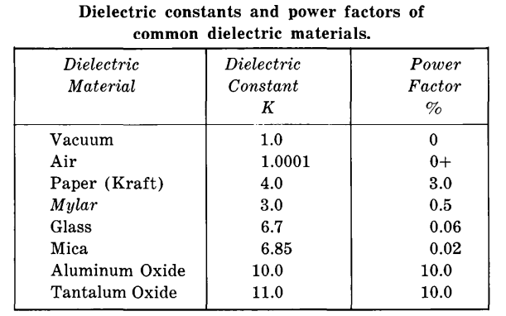

* **Dielectric Stress:**

Excessive voltage weakens an insulator’s dielectric strength, making it prone to future failure even at rated voltage. Dielectric quality is crucial, as impurities, especially metallic ones, create weak spots leading to breakdown. Paper capacitors use multiple layers to reduce impurity effects. Dielectric stress, measured in volts per mil, decreases with rising temperature, frequency, or material thickness.

* **Temperature:**

Capacitors are highly affected by temperature changes, with 25°C being the optimal rating. Higher temperatures increase capacitance but reduce voltage-breakdown resistance, while lower temperatures do the opposite. Both cases lead to a higher power factor. Though most capacitors follow this trend, some, like ceramic types, are designed to decrease in value with rising temperature. The main cause of these effects is increased electron activity, which can lead to dielectric breakdown at higher temperatures.

* **Plate Losses:**

The overall performance of a capacitor depends mainly on dielectric and plate efficiency. Aluminium is the most common plate material due to its stability, despite lower conductivity than copper. As temperature rises, both plate and dielectric efficiency decrease, increasing overall losses. While capacitance may increase with temperature, overall efficiency declines.

* **Equivalent Capacitor Circuit:**

A real capacitor has imperfections, unlike an ideal one with no losses. Every conductor, including capacitor plates, has some inductance, which increases when the plates are rolled into a cylinder or coil. Capacitors also have leakage resistance (R₁), which varies widely but can still allow proper function. Additionally, the effective series resistance (R₂), caused by lead and plate losses, is much lower than leakage resistance and helps in efficiency calculations.

* **Capacitance Measurement:**

By definition, a capacitor is a device capable of temporarily storing electrical energy. That is, the device is said to have capacitance. How does one measure capacitance? One way is to compare the capacitor against a known standard by means of a bridge circuit. Another is to use a wattmeter, which measures the actual amount of energy. The latter is probably the only true means of fulfilling the requirements of the following formula for capacitance:

where,

C is the capacitance in farads,

Q is the quantity of charge in coulombs ( one coulomb is equal to a current of one ampere flowing for one second),

V is the voltage across the capacitor plates.

As an example, assume we charge a capacitor to 500 volts and then discharge it through a sensitive watt/second meter, getting a reading equivalent to one ampere/second of current flow. Solving the equation, we find that C = 1/500, or .002 farad (2,000 mfd).

The time-constant method is another way of measuring capacitance with substantially the same accuracy.

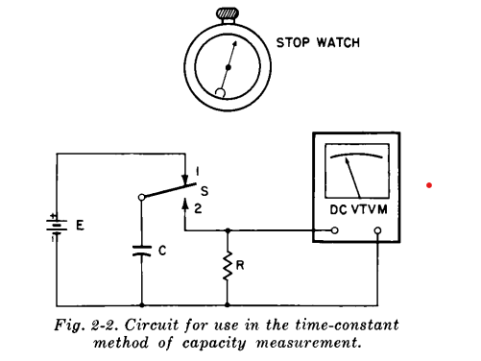

This admittedly is a rather crude test, since a stopwatch is used, but it serves to depict the principle involved. E is the energy source, S is a single-pole-double-throw switch, R is a 1,000-ohm resistor, and C is the capacitor under test. A sensitive vacuum-tube voltmeter, with an input resistance of a least 1,000 times the value of R, is used for the voltage readings. While the switch is in position 1, the capacitor remains charged. To start the test, we simultaneously depress the switch to position 2 and start the stopwatch. When the VTVM reads approximately 37% of the maximum voltage reading, we stop the watch. Capacitance can now be calculated from the following equation:

where,

C is the capacitance in farads,

t is the time in seconds,

R is the resistance in ohms.

For purposes of illustration, assume two seconds has elapsed. The equation is solved to give C = 2/1000, or .002 farad (2,000 mfd). If the time had been one second, the answer would have been 1,000 mfd, and so on. This test is only as accurate as the timing method used. The one described would be useless for small capacitors. However, by substituting an oscilloscope equipped with a millisecond timing pulse, we could achieve a high degree of accuracy.

* **Capacitor Operation:**

Initially, when voltage is applied, it offers minimal resistance, allowing maximum current flow. As charge accumulates, opposition to further charging increases until the capacitor reaches the applied voltage and current flow ceases. The speed of charging depends on capacitance and resistance, affecting circuit performance in high-frequency applications.

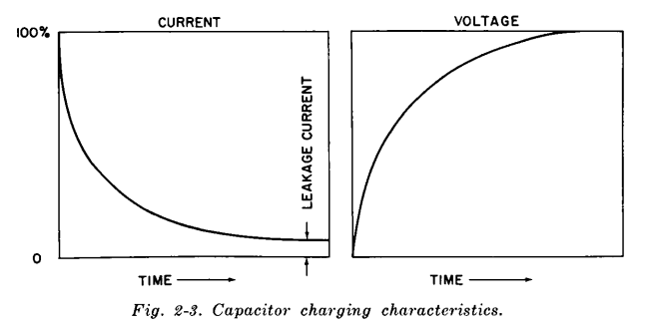

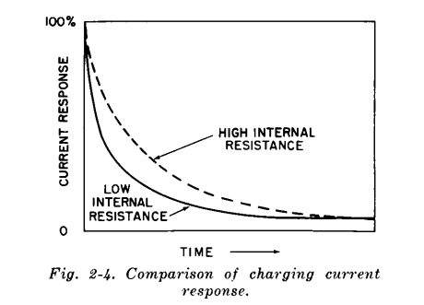

Discharging follows a similar curve, starting rapidly and then tapering off. However, due to dielectric absorption, some charge remains trapped within the dielectric material, causing the capacitor to regain a small charge even after being discharged. This occurs because not all electrons redistribute evenly, making it impossible to completely discharge a capacitor after exposure to a DC charge.

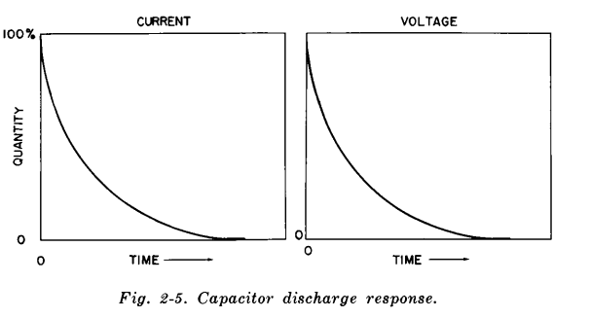

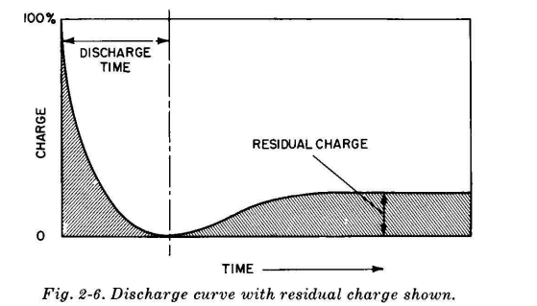

* **Time Constant:**

The charge and discharge cycles of a capacitor depend on time, which is crucial for capacitance measurement and circuit performance analysis.

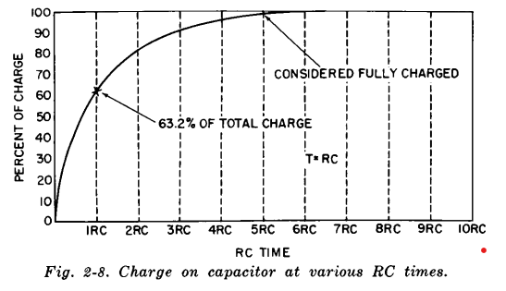

The RC time constant (τ = RC) represents the time required for a capacitor to charge to 63.2% of the applied voltage. In 5 RC times, it is considered fully charged. Discharge follows the same rule, but different resistances can create varying charge and discharge rates. This principle is used in circuits like neon lamp oscillators, where a capacitor charges slowly and discharges rapidly, producing a sawtooth waveform.

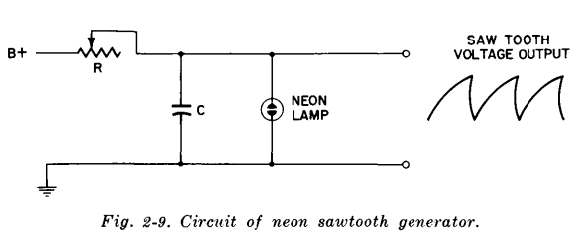

The frequency of the sawtooth waveform depends on the values of R, C, and the neon lamp characteristics. By varying R, the repetition rate of the waveform can be adjusted.

* **Capacitive Reactance:**

Capacitive reactance is the opposition a capacitor offers to the flow of AC due to the charge-discharge process. It depends on the frequency of the applied AC voltage and is measured in ohms. Higher frequency allows less time for charging, reducing reactance, while lower frequency increases it.

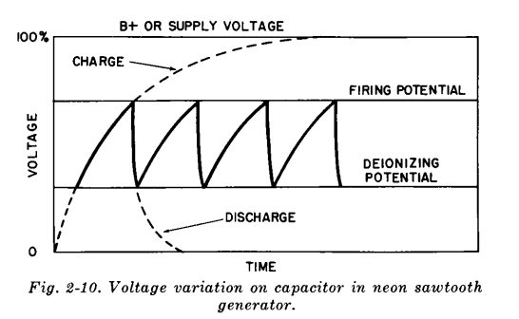

Capacitive reactance is expressed by the formula:

**Xc**

where,

**Xc** is the capacitive reactance in ohms.

**f** is the frequency in cycles per second.

**C** is the capacity in farads.

Capacitive reactance decreases as frequency or capacitance increases, while at DC, it becomes infinite, preventing electron flow once the capacitor is fully charged. At high frequencies, the capacitor does not charge or discharge significantly, causing most of the voltage to appear across the resistor instead. This behaviour is useful in coupling circuits, where AC signals are transmitted while DC components are blocked.

* **Impedance:**

In circuits with resistance and capacitance, impedance (Z) represents the total opposition to electron flow when AC voltage is applied. It combines resistance (R), which remains constant, and capacitive reactance (Xc), which varies with frequency. When resistance and capacitance are in series, impedance is calculated using the formula Z = where all values are in ohms. An example demonstrates how impedance changes at different frequencies by calculating the capacitive reactance for a 100-ohm resistor in series with a 0.1-µF capacitor at 1,000 Hz and 10,000 Hz. . First we must find the capacitive reactance:

**Xc**

At 1,000 cps:

**= 1,590 ohms**

At 10,000 cps:

**= 159 ohms**

Notice that X" is 10 times greater at 1,000 than at 10,000 cps, illustrating that capacitive reactance is inversely proportional to frequency. Now using our impedance formula: At 1,000 cps:

Z=

At 10,000 cps:

Z=

The change in impedance is not proportional due to the presence of the resistive element. This highlights that the total opposition to electron flow varies with frequency, meaning each frequency experiences a different level of impedance in the circuit.

* **Resonance:**

Capacitors in combination with inductors form circuits capable of discriminating between different frequencies. These are generally known as tuned, or resonant circuits because they respond only to frequencies in the resonant range. Where a range of selection or rejection is desired, variable capacitors or inductors are employed.

**Types of Capacitors:**

* **Air Capacitors:**

Air-dielectric capacitors are valued for their near-zero power factor, excellent stability, and cost-effectiveness. They have capacitance ratings from about 3 mmf to over 330 mmf, with voltage limits around 30,000V DC. Available in fixed or variable forms, they are easy to construct.

Fig. 3-3 shows the basic arrangement of a simple single plate air capacitor. The plates of the fixed unit (Fig. 3-3A)

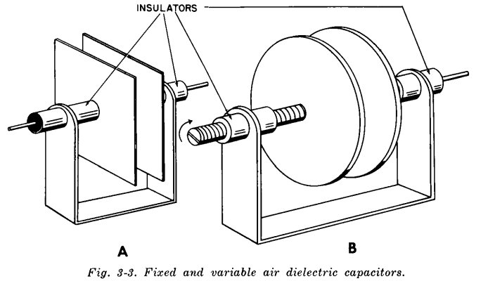

capacitance is varied by altering the overlapping area of the plates rather than the distance between them. This design maintains a consistent breakdown voltage, making it more reliable and widely used in practical applications.

The much more e common variable air capacitor is shown in Fig. 3-4. This is the constant-gap type, in which the

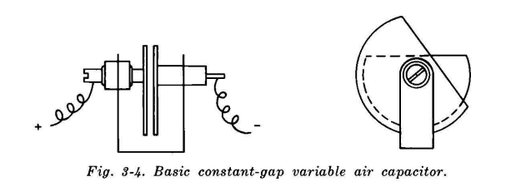

constant-gap variable air capacitors adjust capacitance by changing the overlapping plate area while maintaining a fixed plate distance, ensuring consistent voltage breakdown resistance. Their design can be modified by adding multiple plates or shaping them for specific capacitance or frequency variation, making them ideal for tuning and trimming applications.

Air-dielectric capacitors, though inefficient in terms of size versus capacitance, offer excellent stability, minimal temperature effects, and a long lifespan. Commonly made with aluminium rotor plates, they can also be plated with silver or nickel for better performance. Their main drawbacks include susceptibility to humidity, which can cause arcing, and plate vibrations at high frequencies. To counteract atmospheric effects, some are sealed in evacuated or gas-filled cases, while others in transistor radios are encased in plastic to prevent dust-related interference.

* **Paper and Film Capacitors:**

The need for higher capacitance led to the development of compact capacitors using oil- or wax-impregnated Kraft paper as a flexible and efficient dielectric.

Paper capacitors are made by rolling metal foils with multiple thin paper layers, which are vacuum-dried and impregnated with wax, mineral oil, or synthetic materials to enhance voltage rating and durability. Thinner paper reduces voltage stress, improves impregnation, and minimizes conductive paths. Wax offers the lowest quality and temperature stability, while mineral oil ensures better stability, and synthetics allow for smaller, high-voltage capacitors. For better performance, multiple tabs or the extended-foil method are preferred over single-tab connections.

https://github.com/PreethaSM87/githubhtml/blob/c0470d706bbbc2ec2c45fb90d2432c4c47c259ed/udemy-logo.png 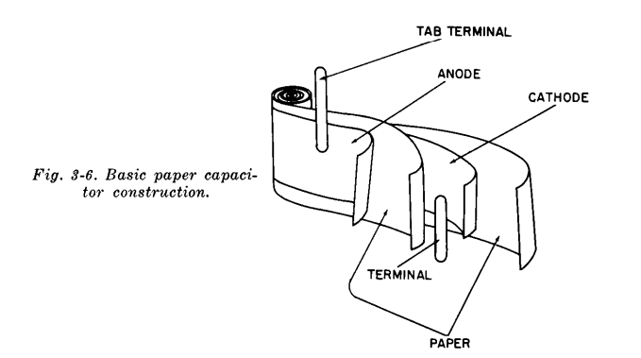

Fig. 3-7 shows the basic construction of an extended-foil capacitor. It is essentially noninductive, since all layers for one plate are mutually joined at one end. Another advantage of this construction is its lower internal resistance. How 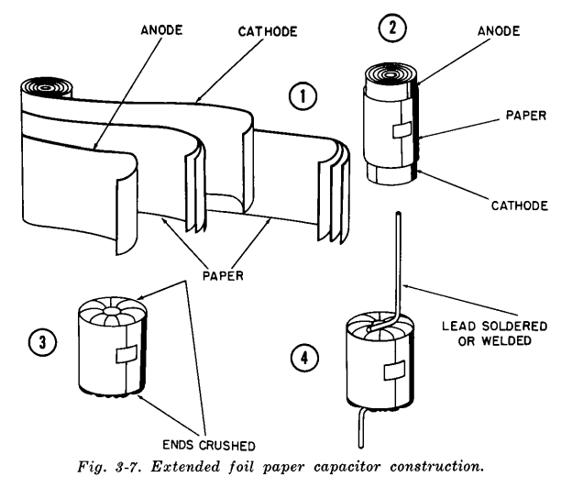

paper capacitors are limited by high-temperature sensitivity due to impurities that accelerate degradation. While they can withstand high voltages—especially mineral-oil types—they are being replaced by plastic film capacitors like polystyrene and Mylar, which are more stable, compact, and heat-resistant. However, plastics have lower corona-starting voltage and are unsuitable for high-voltage buffer applications.

Polystyrene capacitors have better temperature stability than Mylar but are limited to +85°C, whereas Mylar operates up to +130°C. Oil-filled plastic capacitors are used for high-voltage applications. Metallized paper capacitors combine paper and Mylar with a vacuum-plated aluminium film that offers self-healing properties but may cause noise issues. Plastic film capacitors are housed in plastic or metal cases for better moisture resistance. Paper capacitors have a surge voltage rating that should never be exceeded, even during testing, to prevent failure.

* **Mica Capacitors:**

Mica capacitors, though being replaced by ceramic and glass types, are smaller than air capacitors due to mica’s superior dielectric properties—nearly seven times better than air. Mica’s ability to be sliced thin increases capacitance, and its resistance to humidity ensures high stability.

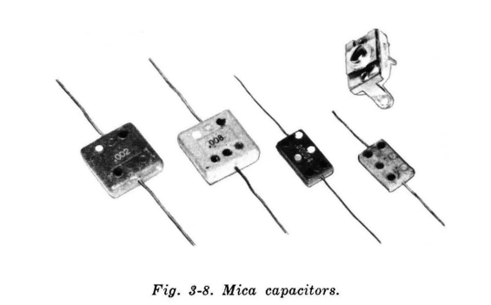

Mica capacitors come in values from 1 mmf to 1 mfd, with voltage ratings up to 35,000 VDC. They are available in both fixed and variable types, with two main styles: foil and deposited silver.

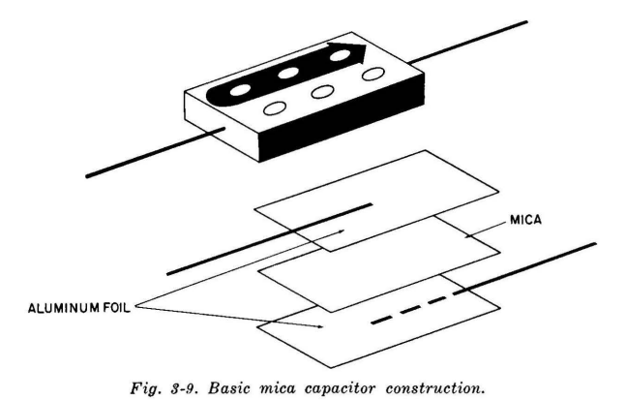

silver mica capacitors have silver directly deposited onto the mica sheet, improving capacitance and stability. However, under high voltage and moisture, silver particles may migrate, causing failure. Button mica capacitors, though fragile, offer lower inductance and high leakage resistance.

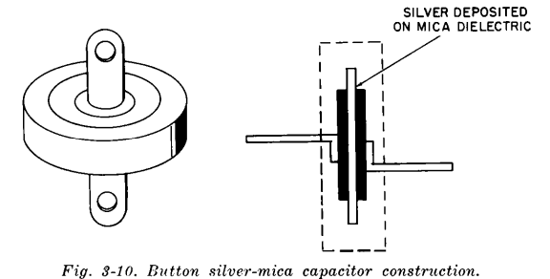

Variable mica capacitors (Fig. 3-11) are common in trimmer applications.

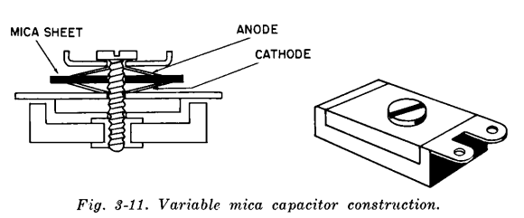

Trimmer capacitors adjust capacitance by tightening or loosening a screw to change the plate distance. Mica is commonly used as a dielectric in trimmers due to its moisture resistance, ensuring stability and reliability.

* **Ceramic Capacitor:**

Ceramic capacitors are highly versatile and widely used due to their compact size, stability, and adaptability. The most common type is the **disc capacitor**, but **tubular** and **rolled** types are also available. They offer a wide range of capacitance values and are used in various electronic applications.

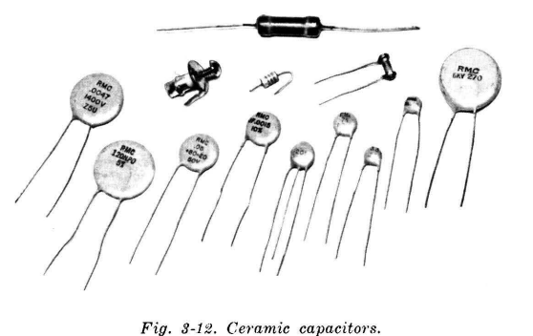

Ceramic capacitors come in a wide range of capacitance values (0.5 mmf to 0.1 mfd) and voltage ratings (up to 30,000 VDC, with surge ratings up to 40,000 VDC). They are available in disc, tubular, and rolled forms, with the tubular type offering both fixed and variable capacitance. Ceramic capacitors provide a good size-to-capacitance ratio and are categorized into general-purpose,temperature-compensating, temperature-stable, and frequency-stable types, making them suitable for various electronic applications like filtering, bypassing, and coupling circuits.

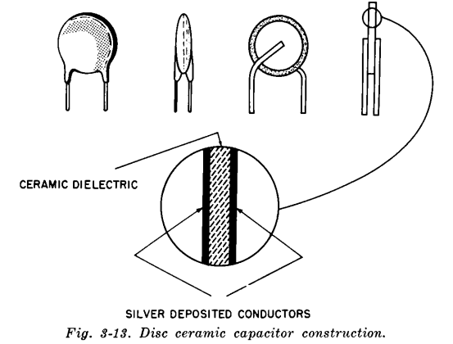

Temperature-compensating ceramic capacitors maintain stable capacitance across a wide temperature range, with some varying by +15% to -10%. Their capacitance change is measured in ppm/°C from +25°C to +85°C. The prefix-letter system classifies them as P (positive coefficient, increasing capacitance), N (negative coefficient, decreasing capacitance), or NPO (zero coefficient, no change). The larger the number after P or N, the greater the variation, while NPO capacitors remain stable.

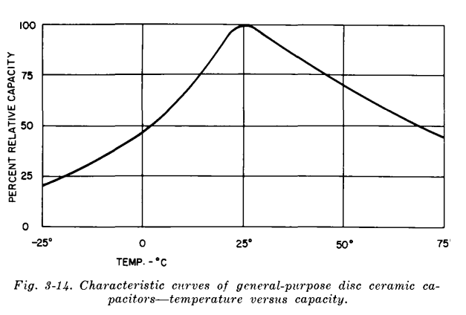

Temperature-compensating ceramic capacitors adjust capacitance to counteract temperature-induced variations in circuits, with designations like P100 (increasing 100 ppm/°C) or N750 (decreasing 750 ppm/°C). Temperature-stable ceramics refine this concept, operating from -60°C to +110°C with only ±7.5% variation, making them ideal for stable circuit performance.

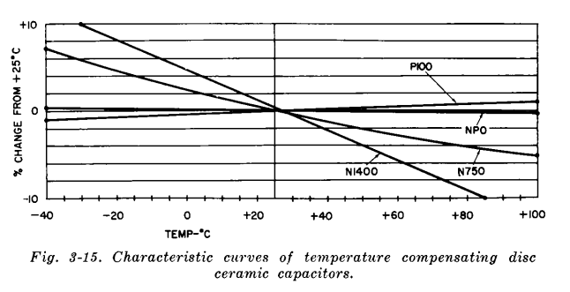

Frequency-stable disc ceramic capacitors maintain a consistent resonant frequency over varying temperatures, unlike other types. However, their use of materials with higher power factors makes them more prone to charge-discharge cycle issues.

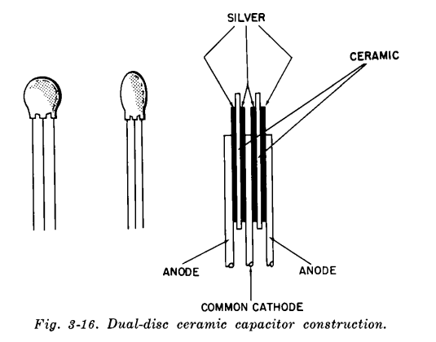

Disc ceramic capacitors are typically used individually, but dual-section types exist to prevent mutual coupling from affecting circuit performance. Tubular ceramic capacitors function similarly to Leyden jars, featuring a ceramic dielectric tube with silver-plated inner and outer surfaces, and can have axial, radial, or specialized feedthrough leads.

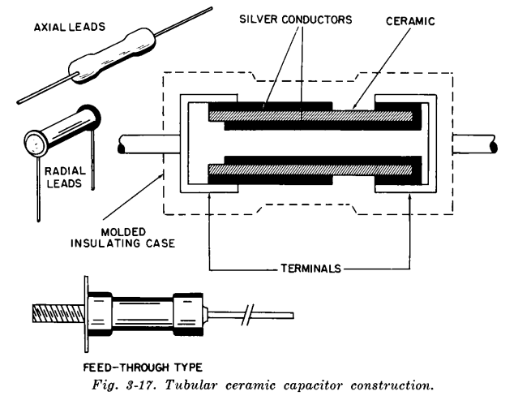

Tubular ceramic capacitors have a lower size-to-capacitance ratio and higher inductance than disc types, making them less commonly used except for feedthrough applications. They are also more fragile than disc ceramics. Due to their excellent dielectric properties, ceramics are increasingly replacing mica capacitors in trimmer applications, with two main designs: concentric tubular units and air-variable-like configurations.

The variable tubular capacitor consists of a silvered outer ceramic tube with a stationary plate inside and a movable inner ceramic tube with an internal silvered surface. Adjusting the position of the inner tube changes the effective plate area, thereby varying the capacitance, typically within a range of 1 to 8 mmf.

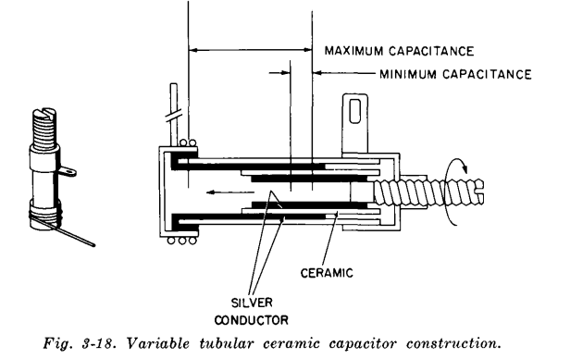

Tubular variable ceramic capacitors offer precise but small capacitance adjustments, while disc-type trimmers provide larger capacitance changes with a 180° rotation.

Door-knob ceramics are used in TV high-voltage applications to prevent flashover, and laminated ceramic capacitors allow universal replacement by adjusting lead connections, though with some size and performance trade-offs.

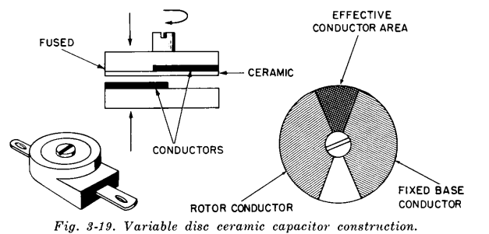

Ceramic capacitors, especially disc types, are widely used but are sensitive to moisture, fragile, and can be damaged by excessive pressure on leads or overheating during soldering.

* **Electrolytic Capacitors:**

Electrolytic capacitors offer the highest capacitance for their size but can be confusing due to their unique characteristics. They follow different rules compared to other capacitors yet perform essential functions that no other type can.

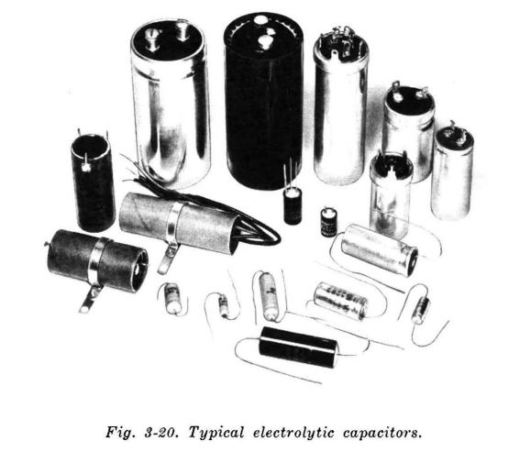

Electrolytic capacitors differ from other capacitors in construction. They use an aluminium anode coated with an aluminium oxide film as the dielectric, while a liquid electrolyte acts as the cathode, with a second metallic conductor (usually aluminium) providing an external connection.

In practical applications, porous paper is wrapped around the anode and saturated with the electrolyte to prevent spillage.

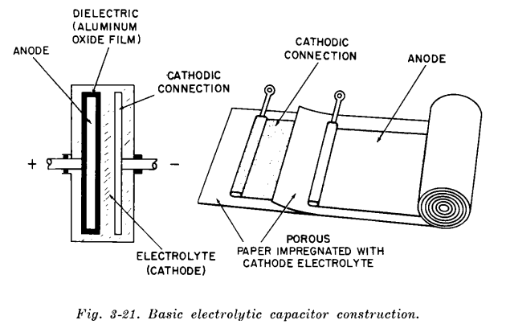

Electrolytic capacitors are polarized due to their aluminium oxide dielectric. Reversing polarity causes failure. They come in polarized, semi polarized, and non-polarized types, with non-polarized ones suitable for AC applications.

Nonpolarized electrolytic capacitors have oxide coatings on both plates, making them suitable for AC applications like motor starting. However, they are larger in size compared to polarized types.

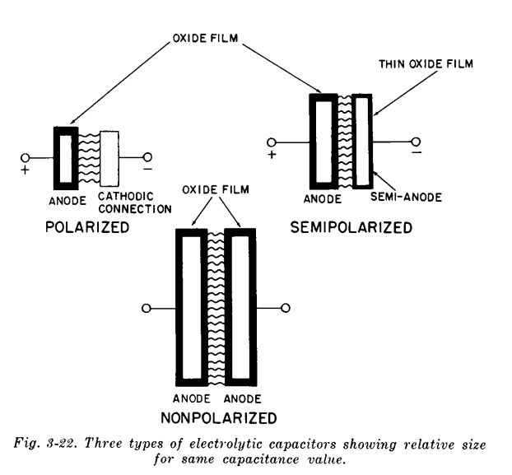

Electrolytic capacitors use an aluminium anode with an etched surface to increase capacitance. They are polarized, requiring correct voltage orientation to prevent failure. Variants include polarized, semi polarized, and nonpolarized types, with nonpolarized ones used in AC applications. They have higher leakage currents, which increase with temperature, and their capacitance decreases at low temperatures. Extended inactivity can degrade them, requiring a controlled reformation process. Care must be taken during installation, as some high-capacitance units can retain a lethal charge.

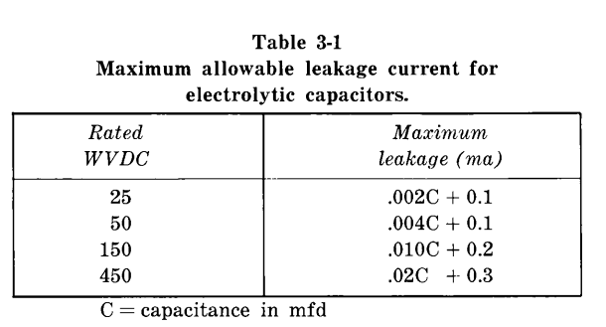

* **Tantalum Capacitors:**

Tantalum capacitors, mainly used in military and high-quality electronics, offer the highest capacitance per size. Despite their high cost due to the rarity of tantalum, they are corrosion-resistant and have a high melting point. Similar to aluminium electrolytics, they come in polarized, nonpolarized, and sintered anode forms, making them ideal for compact electronic devices.

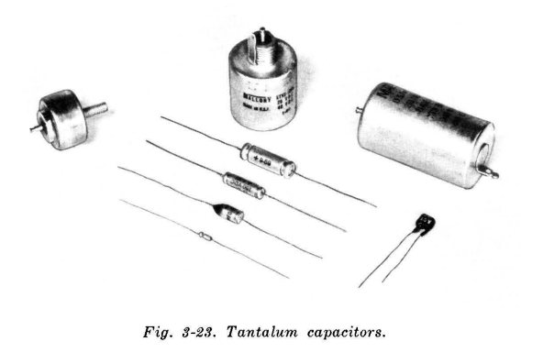

Tantalum capacitors offer excellent stability, a wide operating temperature range (-80°C to +200°C), and long storage life without needing reformation. They come in values from 0.25 to 2,200 µF and voltages up to 640V, available in both polarized and nonpolarized forms, with either wet or solid electrolytes.

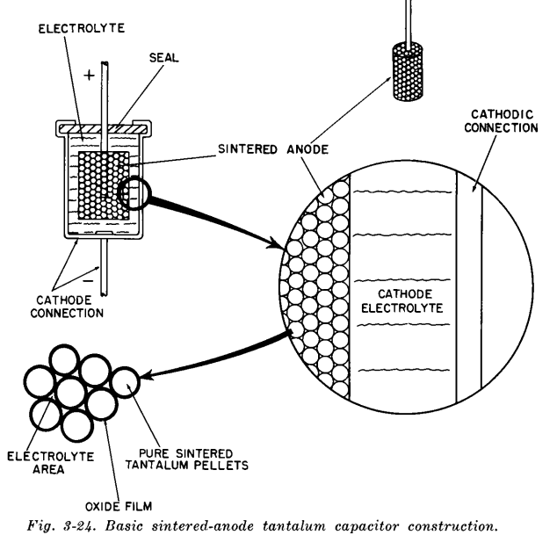

Tantalum capacitors, particularly solid electrolyte types, are made similarly to wet types but use a vacuum-impregnated solid electrolyte instead of liquid. This enhances adhesion and durability while simplifying sealing by mainly preventing external contamination. Some variants have flat anodes with epoxy encapsulation, making them suitable for printed circuit boards. As a relatively new technology, tantalum capacitors continue to improve, and increasing production may lower costs, leading to broader use in consumer electronics.

* **Specialized Capacitors:**

Glass and vitreous enamel capacitors are specialized types used as high-grade alternatives to mica and ceramic capacitors in demanding conditions. Glass dielectric capacitors consist of layered glass ribbon and metal, fused into a solid block, providing excellent moisture resistance due to their seamless design. Vitreous enamel capacitors use a glazing material instead of glass but are prone to cracking under extreme temperature changes. Both types can endure high acceleration forces but are physically fragile. While their performance is similar to mica capacitors, they lack the temperature compensation of ceramic types and are mainly used in high-humidity environments.

**Applications of Capacitors:**

**1. Energy Storage**

Capacitors store electrical energy by accumulating charge on their plates. They can quickly charge and discharge, making them ideal for applications requiring rapid bursts of energy.

* + In power supplies, capacitors act as temporary energy reservoirs, providing power during brief interruptions or fluctuations.
* Supercapacitors (or ultracapacitors) are used in regenerative braking systems in electric vehicles, where they store energy when braking and release it when needed for acceleration.

**2. Filtering:**

Capacitors play a crucial role in removing unwanted noise and stabilizing voltage in electronic circuits.

* In power supply circuits, they smooth out fluctuations in DC voltage by filtering out ripples from rectifiers, ensuring a steady output.
* In audio systems, capacitors filter out high-frequency noise and interference, improving sound quality.

**3. Coupling and Decoupling:**

Capacitors help in signal transmission and noise reduction in various circuits.

* Coupling capacitors allow AC signals to pass from one stage of a circuit to another while blocking DC components. This is useful in amplifiers and communication circuits.
* Decoupling capacitors (also called bypass capacitors) stabilize voltage by filtering out transient voltage spikes, preventing noise from affecting sensitive electronic components.

**4. Timing Circuits:**

Capacitors work with resistors in timing circuits to control the duration of electrical pulses.

* In oscillators and clock circuits, capacitors help in frequency generation for microcontrollers, processors, and radio transmission.
* Timers, such as the 555 timer IC, use capacitors to determine the delay before triggering an output signal.

**5. Signal Processing and Frequency Tuning:**

Capacitors are essential in electronic devices for frequency-dependent applications.

* In radio and television receivers, tuning capacitors adjust the frequency of circuits to receive desired signals.
* Capacitors are used in equalizers and audio filters to manipulate sound frequencies, improving audio quality.

**6. Motor Starters and Power Factor Correction:**

Capacitors are widely used in AC motors to enhance efficiency and performance.

* In single-phase induction motors, capacitors create a phase shift to generate a rotating magnetic field, aiding in motor startup and operation.
* Power factor correction capacitors are used in industrial power systems to reduce reactive power, improving energy efficiency and lowering electricity costs.

**7. Flash Circuits and High-Voltage Applications:**

Capacitors provide rapid energy discharge for applications requiring sudden bursts of power.

* In camera flash units, a capacitor charges and then releases a high-voltage pulse to generate a flash of light.
* In pulse lasers and high-intensity discharge lamps, capacitors deliver short, powerful energy bursts.

**8. Memory Storage in Computers:**

Capacitors are used in computer memory to store and process data.

* Dynamic RAM (DRAM) relies on capacitors to store binary information (0s and 1s) in tiny charge packets. Since capacitors slowly discharge, DRAM requires periodic refreshing to maintain data.
* Non-volatile memory systems sometimes use capacitors for backup power to retain data temporarily during sudden power failures.

**9. Medical Applications:**

Capacitors play a critical role in medical devices and healthcare technology.

* In defibrillators, capacitors store electrical energy and deliver controlled shocks to the heart to restore normal rhythm in cardiac emergencies.
* Medical imaging systems, such as MRI and X-ray machines, use capacitors in their power supply circuits to stabilize voltage.

**10. Sensors and Transducers:**

Capacitors are used in sensor technology to measure changes in environmental conditions.

* + Capacitive touchscreens in smartphones and tablets detect touch by measuring changes in capacitance.
* Capacitive proximity sensors are used in automation systems to detect objects without physical contact.

**Conclusion on Capacitors:**

Capacitors are fundamental components in electrical and electronic circuits, known for their ability to store and release electrical energy. Their diverse applications span across power management, signal processing, filtering, timing circuits, energy storage, and medical devices. They play a crucial role in improving efficiency, stability, and functionality in everything from household electronics to large industrial systems.

With advancements in materials and technology, capacitors continue to evolve, leading to higher energy storage capacities, improved efficiency, and greater reliability. Innovations such as supercapacitors are revolutionizing energy storage, making them a key component in renewable energy, electric vehicles, and high-power applications.

Overall, capacitors are indispensable in modern technology, and their continued development will drive progress in electronics, communication, healthcare, and power systems. Their versatility ensures that they remain a cornerstone of electrical engineering and innovation.